WHY DO WE EAT?

Animal Cells and Metabolism

MIDDLE SCHOOL UNIT

STUDENT PAGES

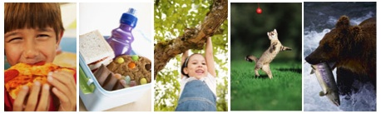

March 2009

Michigan State University

Environmental Literacy Project

Lindsey Mohan and Andy Anderson

Name: __________________________________________ Date: _____________________
Exploring Food Labels
Your group will be given food labels. Look at each label carefully and fill in the table below. Once you have looked at all your food labels, discuss the questions on the following page. Think carefully about these questions and write down as much as you can because you will need to share your ideas with the class.

Food Label Data Table: |  | Chemical Energy |  |  |  | Other Things
Label | FOOD NAME | How many calories does it have? | How many carbohydrates does it have? | How much fat does it have? | How much protein does it have? | What types of vitamins and minerals does it have? | Is this “food” using our definition of food?  YES or NO
1
2
3
4
5
6
7
8

9

Exploring Food Label Questions
- Which things in your list are “food” using our definition of food?
__________________________________________________________________________________________________________________________________________________________________________________________________________________

2. Why are these things food? What do they provide your body that makes them food? ______________________________________________________________________
__________________________________________________________________________________________________________________________________________________________________________________________________________________

3. What things in your table are NOT food (do not have chemical energy)?
__________________________________________________________________________________________________________________________________________________________________________________________________________________

4. What is the difference between things that are food for your body and things that are not food? ______________________________________________________________ ________________________________________________________________________________________________________________________________________________________________________________________________________________________________________________________________________________________

5. Do you have any ideas about what happens to food once it goes inside your body (How does the body get the chemical energy in food)? __________________________
________________________________________________________________________________________________________________________________________________________________________________________________________________________________________________________________________________________
Name:____________________________________ Date: _________________

Why do we need to breathe and eat?

Every day you breathe in and out about 20, 000 times! In your lifetime so far, you’ve breathed in and out about 9, 000,000 times! You’ve also eaten food three to four times a day since you’ve been alive. That’s about 15,000 meals in your lifetime so far! Eating and breathing are obviously very important to you—you do them both all the time. You have to eat and breathe to stay alive. Have you ever wondered why your body needs so much oxygen and food? What happens to all that air and food you take into you body? Do you know why breathing and eating are necessary for life? Most of us eat and breathe every day and have no idea why! Today you will learn why you eat food all the time. Then you will learn about the air that you breathe. You will get to know something about things going on inside your own body right this very minute. Then you will understand why it is necessary for you to breathe and eat.

Think of taking a bite of pizza. What happens to the pizza once it is inside your body? Think about and discuss the following questions with your class:

- After you eat the pizza, where does it go inside your body? ____________________
__________________________________________________________________________________________________________________________________________________________________________________________________________________

- Do you think your body uses the materials in the pizza to grow? If so, how? _______
____________________________________________________________________________________________________________________________________________

3. Do you think your body uses the materials in the pizza to walk and run? If so, how?
______________________________________________________________________
______________________________________________________________________

Name:_____________________________________ Date: _________________

What Happens to the Food We Eat?
Earlier you were asked to respond to the question: What happens to the food that we eat?

You might have written an answer similar to the ones below:
- We need to eat because we would die without food.
- We need to eat because food helps us live and grow.
- We need to eat because food is our cells’ only source of chemical energy.

All three statements are correct, but they are not all good explanations of why we need to eat. Scientists would say that the third answer is the best one because it explains HOW our bodies use the food we eat: food is our cells’ only source of chemical energy.

Food is our only source of energy. All the trillions of cells in our bodies need food because it has chemical energy. If all of your cells need food, how do you think food gets to all the cells in your body? Food definitely enters your mouth, but how does food reach cells in your toes? Your thumb? Your ears?

Think about taking a bite out of an apple. That bite of apple is really a mixture of many different materials. It contains many materials your body can use: water, vitamins and minerals, and sugars. Which of these are materials that provide your body with chemical energy?

1. Does the water provide your body with chemical energy? __________
2. Do the vitamins and minerals provide your body with chemical energy? __________
3. Does the sugar provide your body with chemical energy? __________

Let’s trace this bite of apple through your body: from your mouth to cells in your toes!

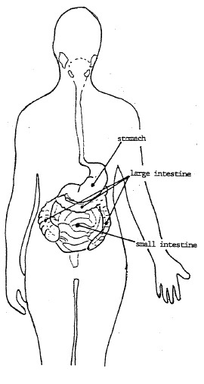
Stomach and small intestine
As you chew the bite of apple, you mash it up with your teeth and mix it with the saliva in your mouth. Then you swallow. The apple’s first stop is your stomach. It is mixed with digestive juices and is sent on to your small intestine. There, different parts of your apple bite go different ways.

The useless parts of the apple – the fibers, bacteria, and dirt – keep going through your intestines. They go from the small intestine to the large intestine and then right out of your body as feces.

The useful parts of the apple – the water, vitamins and energy-containing food – do NOT go on to the large intestine. They are carried to all the cells of your body.

4. What might carry them there? ___________________________________________
__________________________________________________________________________________________________________________________________________________________________________________________________________________

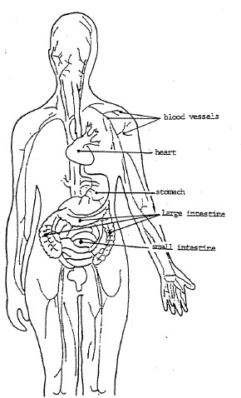
Your blood
Your blood! Food and other useful materials go through the walls of your small intestine and into tiny blood vessels. Then the blood carries those useful materials all over your body. A blood vessels pass near every single living cell in your body! The cells take the materials they need from your blood. Most people don’t realize how MANY tiny blood vessels they have in their bodies. We tend to think about the big vessels that we can see by looking carefully at our skin. But there are millions of tiny blood vessels in our body. If we lined them up end-to-end, they would go twice around the earth!

5. Why do we need so many tiny blood vessels? _______________________________
__________________________________________________________________________________________________________________________________________________________________________________________________________________

Your cells take the food they need out of your blood.

Then your cells do one of several different things with the food:
- GROWTH & STORAGE: Some food is used by cells to make new cells. That’s how you grow. If you eat more food than you need, some of the food is stored for the future. Fat is your body’s way of storing extra food.
- USE: Most of the food that reaches your cells is broken down to supply energy for your cells to work. This is how your body keeps all its parts working!

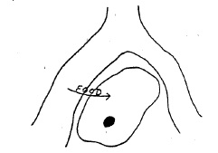

6. Describe how a muscle cell in your finger gets the food it needs to give it the energy needed to write this answer. Describe the path food takes to get to your cell and the things that might happen to food once it reaches your cells.
____________________________________________________________________________________________________________________________________________________________________________________________________________________________________________________________________________________________________________________________________________________________________________________________________________________________________
Name: _______________________________________ Date: ________________

Mealworm Observations

My Measurements:

 |  | Start Mass Observation #1 | Observation  #2 | Observation #3 | Observation # 4 | End Mass Observation  #5 | Change
1 | Food |  | Do not need to record
2 | Mealworms |  | Do not need to record
3 | Food and mealworms
4 | Food, mealworms, and cup

Mass of empty cup: ____________ Use this number to help you find out the mass in line 3 during Observations 1-5.
Questions about Mealworm Observations

1. Did the mass of your mealworms increase or decrease? ______________________

2. Did the mass of your food increase or decrease? ____________________________

3. How does your data show that some of the food eaten by mealworms helps them grow? ________________________________________________________________
________________________________________________________________________________________________________________________________________________________________________________________________________________________________________________________________________________________

4. Did the combined mass of the food and mealworms increase or decrease? ______________________________________________________________________

5. If the mass decreased, where do you think the matter went?
________________________________________________________________________________________________________________________________________________________________________________________________________________________________________________________________________________________

6. There is chemical energy in food. How do you think this chemical energy changes when the mealworms grow? _______________________________________________
__________________________________________________________________________________________________________________________________________________________________________________________________________________

Name: _________________________________ Date: __________

What Happens When Animals Grow?

1. What happens to matter and energy when the mealworms grow?
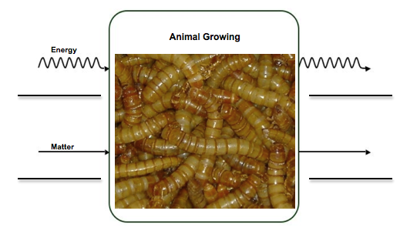
2. Using what you learned in your investigation, show what happens to matter and energy in our own bodies when we grow.
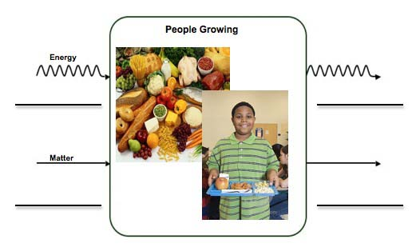
Name: ____________________________________ Date: ____________

Food Helps Animals Move

- Think about how food and air help you move and exercise. How does matter and energy change in your body when you move and exercise?
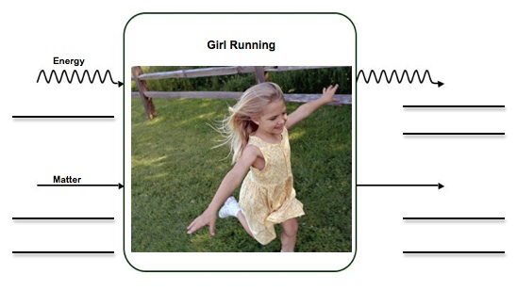

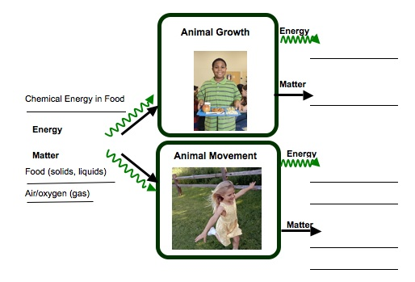
- Some food and air helps animals grow and some helps animals move. Trace the two different paths that matter and energy take in the body.
Name: ___________________________________ Date: ______________

Modeling Cell Respiration

In your groups, you will use molecular model kits to model the process of cellular respiration. You will build the substances that go into cells, and then use the models to show how those substances change inside cells. Follow the directions below to build your models:

Look at the equation for cell respiration:

MATTER Glucose + Oxygen → Carbon dioxide + Water
ENERGY Chemical Energy → Motion Energy + Heat

Glucose is a sugar that comes from food, and oxygen comes from the air that you breathe. In order to model cell respiration, you will first need to build your glucose molecule and your oxygen molecules.
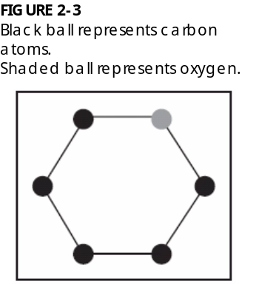

Build Glucose Molecule

Step 1: Build the Glucose Ring. Look at the diagram to the right. This shows the first part of the glucose molecule. It shows 5 carbon atoms (black) and 1 oxygen atom (grey). This ring will start your glucose molecule.

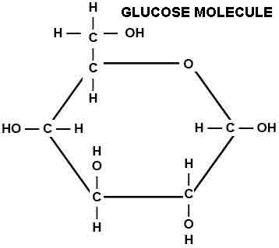

Step 2: Look at the diagram and circle on the right. You will work first with the carbon that is to the left of the oxygen in your ring. On this carbon, first connect a second carbon. On this second carbon, attach 2 hydrogen atoms and 1 oxygen. Attach another hydrogen to the oxygen. Then attach 1 hydrogen to the carbon that is on the ring. There should be no empty holes.
Step 3: Move to the next two carbons on the ring. Attach 1 oxygen and 1 hydrogen to these carbons. Then attach another hydrogen to each oxygen. Make sure it looks similar to the diagram to the right. There should be no empty holes on these atoms.

Step 4: Move to the last two carbons on the ring. Attach 1 oxygen and 1 hydrogen to these carbons. Then attach another hydrogen to each oxygen. Make sure it looks similar to the diagram to the right. There should be no empty holes on these atoms.

Check that there are no empty holes on your glucose molecules and that it looks like the diagram. Now you’re ready to build your oxygen molecules!

Build Oxygen Molecules.

Step 5: You will need 12 oxygen atoms to build 6 oxygen molecules. Each molecule contains 2 oxygen atoms. These are bonded together twice (a double-bond). Build 6 oxygen molecules that look like the molecule on the right,
Look at your glucose and oxygen molecules. Glucose is a sugar that our bodies get directly from food or from breaking down more complex substances. Oxygen comes from the air that we breathe. Count the number of atoms that you have total.

How many carbon atoms are in your molecules? ____________
How many oxygen atoms are in your molecules? ____________
How many hydrogen atoms are in your molecules? ____________

Look at the glucose molecule. Does glucose have chemical energy? Why or why not? _____________________________________________________________________
_____________________________________________________________________

Look at the oxygen molecules. Does oxygen have chemical energy? Why or why not? _____________________________________________________________________
_____________________________________________________________________

Record this information in the table below:
 | Matter |  |  | Energy
 | Carbon atoms | Oxygen atoms | Hydrogen atoms | Chemical Energy  Yes or No?
Glucose
Oxygen
Total Atoms |  |  |  | LEAVE BLANK

Think about this question: Using the information above, do you think oxygen supplies chemical energy for the cell to work?
The glucose and oxygen make in to a cell in your brain. In order for that cell to have usable energy, it must break down the glucose molecule. Use what you know about cell respiration to break down the glucose and oxygen molecules to make the waste products of cell respiration: carbon dioxide and water.

Glucose + oxygen carbon dioxide + water

Below are diagrams of carbon dioxide and water to help you reassemble your molecules. Make as many carbon dioxide and water molecules as you can with the atoms that were originally in the glucose and oxygen.

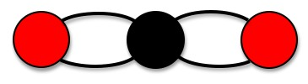
WATER MOLECULE
CARBON DIOXIDE MOLECULE

Once you have made your carbon dioxide and water molecules, count the number of atoms in these molecules.

How many carbon atoms are in your molecules? ____________
How many oxygen atoms are in your molecules? ____________
How many hydrogen atoms are in your molecules? ____________

Check to see that you have the same number of atoms that you started with. There should be no extra atoms either. All of the atoms you began with should be part of either a carbon dioxide or water molecule. Remember atoms cannot be created or destroyed!

Look at the bonds in the carbon dioxide and water molecule. What type of bonds are they? Do you think these molecules have chemical energy? Complete the table below.
 | Matter |  |  | Energy
 | Carbon atoms | Oxygen atoms | Hydrogen atoms | Chemical Energy  Yes or No?
Began with…
Glucose

Oxygen

End with…
Carbon Dioxide
Water

Answer the following questions:
1. The carbon dioxide we breathe out contains carbon. Using what you learned about cell respiration, where was this carbon atom before it was in carbon dioxide? ________
__________________________________________________________________________________________________________________________________________________________________________________________________________________
2. You modeled that cell respiration is a process where cells take food with lots of chemical energy and rearrange the atoms into things that do not have chemical energy. What happens to the energy during this process? ______________________________
__________________________________________________________________________________________________________________________________________________________________________________________________________________
Name: _______________________________________ Date: _______________

Cricket Observations

Use this sheet to make observations of your class crickets.

Your Prediction

- What is the starting mass of your crickets? _____________

- Do you think the mass of your crickets will go up (increase), go down (decrease) or stay the same? ________________________

- Explain your prediction. Why do you think that? _____________________________
_________________________________________________________________________________________________________________________________________________________________________________________________________

Results and Conclusions

- What was the end mass for your crickets? _________________

- If there was a change in mass, explain what you think happened. _______________
____________________________________________________________________________________________________________________________________________________________________________________________________________________________________________________________________________

What Happens When Animals Lose Weight

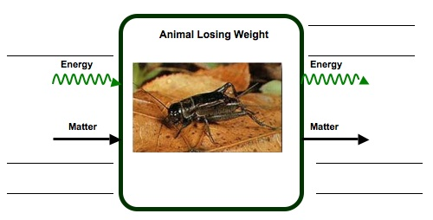
- What do you think happened to the matter and the energy in the crickets?

7. Think about your cricket investigation and what you learned about how animals change matter. When people and other animals lose weight, where does the mass go? What happens to the mass? _______________________________________________
__________________________________________________________________________________________________________________________________________________________________________________________________________________
Name:_____________________________________ Date:_______________
Black Bear Hibernation
Investigation problem*

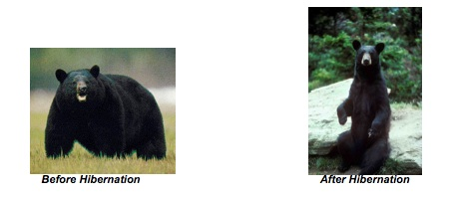

You will explore the following problem:

Why do black bears lose fat during hibernation? Where does the fat go? How can we explain this using the concept of energy?

Procedures:
Read the article - Black Bear Hibernation. As you read think about how the bear gains mass by storing food for hibernation and how the black bear uses its stored fat during hibernation.

After you read the article, complete the energy transformation chart based on what you know about what is happening in the bear. Identify what happens in the cells of the bear and explain how energy and matter change in these cells.

Then in partners or small groups, compare your charts and discuss what you think is happening while the bear hibernate. Discuss the following questions:

What chemical process is happening while the bear hibernates? WHY is this process occurring?
Where does the bear get energy for its body to function while it sleeps? Explains what happens to the energy through this process.
The bear loses mass as it sleeps. Where does this mass go?

After your group discusses the energy charts and the three questions above, then complete the summary questions at the end of the activity. You may be asked to share your ideas or ideas from your group with the rest of the class, so make sure to explain as much as you know about what is happening as the bear sleeps.

BLACK BEAR HIBERNATION

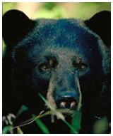

Black bears are classified as members of the order Carnivore, and their teeth, claws, strength, and size make them look like predators. The bears’ body is designed for storing fat and conserving heat in the winter, so they lack the agility required to catch healthy, adult prey. The few prey they catch are mainly nesting birds, newborn mammals, penned livestock, or spawning fish. Their long canine teeth are used mostly for biting into insect-ridden logs or for tearing apart carrion. Their claws are tightly curved for tree climbing, unlike grizzly claws, so black bears have an advantage over grizzly bears, deer, and wild hogs when competing for acorns, nuts, and fruits.

A problem for bears living in northern evergreen forests is that fruits and nuts are very scarce after August. Acorns, beechnuts, and hickory nuts, which are fall foods, are scarce or absent in many of those forests, leaving the bears little food in fall. As a result, the hibernation of black bears is more an adaptation for escaping winter food scarcity than an adaptation for escaping winter cold. In the months before hibernation black bears can gain up to forty pounds of fat per week. Hibernation lasts up to 7 months in the northern regions. Bears that find food year-round in the South may not hibernate at all, but black bears in the North hibernate so deeply that they may be jostled and prodded for several minutes in mid-winter before they awaken. To survive long winters without eating, drinking, exercising, or passing wastes, hibernating bears cut their metabolic rates in half. Sleeping heart rate drops from a summer rate of between 60 and 90 beats per minute to a hibernating rate between 8 and 40 beats per minute. Body temperature drops only slightly, though, from 99-102 °F in the summer to 88-98 °F during hibernation. The body temperature of hibernating bears is appreciably higher than that of other hibernating animals. During the period of hibernation, the black bear usually lose 15 – 25% of its body weight, most of which is fat.

After reading this article, think about information that was given that can help you explain the process happening in the bear and how energy can help explain the loss of fat after hibernation.

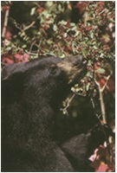
For example, before hibernation bears eat a lot. They eat fruit, nuts, acorns, insects, and certain leaves and plants. They catch occasional small animals, but lack agility to catch most adult prey. In the months before hibernation black bears can gain up to forty pounds of fat per week. Think about the types of molecules that are being made and stored in the bears’ body during the summer and fall months. What do you know about the energy stored in these types of molecules? What does this information tell you about how the bears get and store energy for hibernation?

Think about these questions and complete the first part of the Energy Chart.

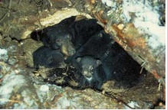
Now think about what happens during hibernation. The sleeping heart rate drops from a summer rate between 60 and 90 beats per minute to a hibernating rate between 8 and 40 beats per minute. The bears’ body temperature drops from regular 99-102°F to 88-98°F during hibernation. But the bear is still alive and all of its body functions are still happening. Where does the bears’ body (and organs) get energy to keep functioning? What metabolic process helps you explain what is happening? What energy transformations are happening during hibernation?

Think about these questions and complete the second part of the Energy Chart.
Summary Questions

First complete the process tool. Then answer the questions below.
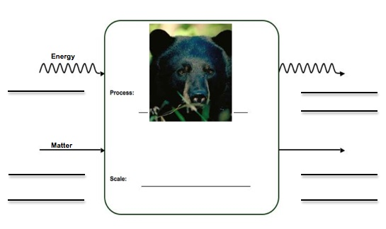

1. Where do you think the mass of the bear’s fat goes during hibernation?

2. Where does the bear get energy for its body to function during hibernation? What form of energy is it?

3. Energy is required to keep the bear’s heart beating during hibernation. Where does the energy come from and how does it change form for the heart to beat?

4. Energy is required to keep the bear’s body temperature warm. Where does the energy come from and how does it change form to keep the bear’s body warm?

READINGS & OTHER RESOURCES
What Is In The Foods We Eat?

You have probably seen nutrition labels that are found on most food packages. Scientists use tests to find out what makes up the foods we eat, and then food companies use labels so that people who buy their products also know what makes up the foods. Today you will work with your group to explore different food labels and you will think about why our bodies need the nutrients found in food. First you need to understand how to read the food labels. Look at the food label below. This food label is for carrots.
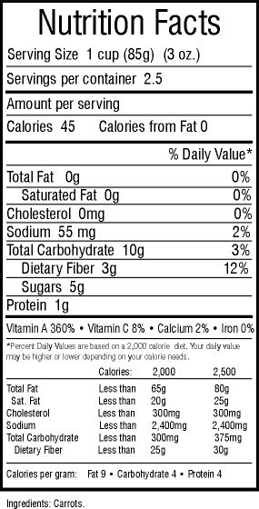

Just by looking at this label, what are some things that make up the carrots that we eat?
Now, take a closer look at the label and think about what each of the things provide our bodies.
What are calories?

Take a look at the things included in the black box. The label shows that there are 45 calories in one serving of carrots. But what does this mean?

Scientist use “calories” to measure how much chemical energy is found in foods. Foods that have calories are a good energy source for our bodies. Things that do not have calories cannot provide energy for our bodies.

Food is our only source of chemical energy. All the trillions of cells in our bodies need food because it’s our only source of energy. Energy is so important to our cells that scientists define food as:

FOOD refers only to materials that contain chemical energy for living things. It is material that living things use for energy to live and grow. All living things must use the chemical energy in food to grow and to keep all their parts working properly.

Now that you know that “food” must provide chemical energy, how can you use the information on food labels to tell you whether something is food or not? Talk with your classmates.
What are the basic building blocks of food?

Some things found in foods have chemical energy but some things do not. The basic building blocks of food are carbohydrates, proteins, and fats. Carbohydrates include sugars, starches, and fiber. Carbohydrates are found in most foods, especially breads, pastas, sweets, and vegetables, like potatoes. Proteins are found in many foods, especially meats, beans, and dairy. Fats are found in many foods, especially oils and butter that we for cooking and baking. These three things have calories, which means they have a lot of chemical energy for our bodies.

Would carbohydrates, proteins, and fats be “food” using our definition of food?

What about vitamins?
Look at the label carefully. Can you find the vitamins and minerals that are found in carrots? What are they?

Vitamins and minerals are important for our bodies to stay healthy. But vitamins and minerals do NOT contain calories, which means they do not provide chemical energy for our bodies.

Would vitamins and minerals be “food” using our definition of food?

Now you will work with a group to look at different nutrition labels. In your group you will need to decide what things are food for our bodies and what things are NOT food.
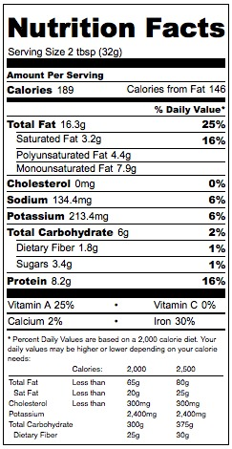
CARROTS
PEANUT BUTTER
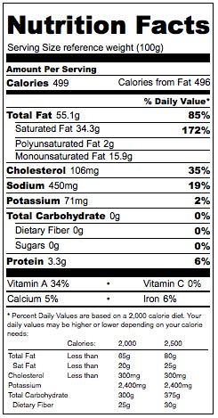
BUTTER
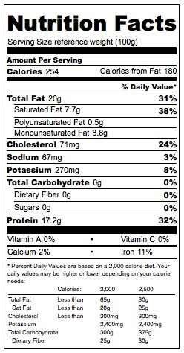
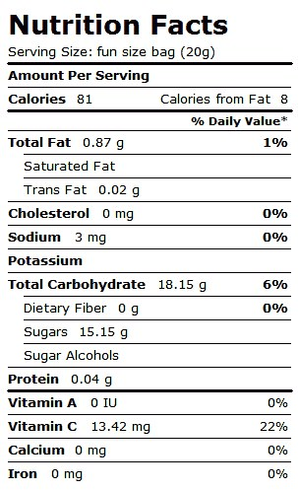
HAMBURGER MEAT
SKITTLES CANDY
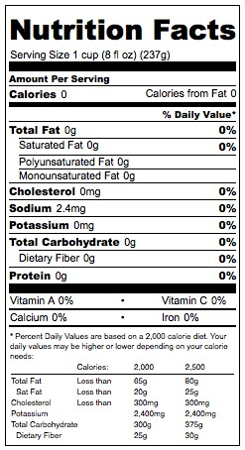
WATER

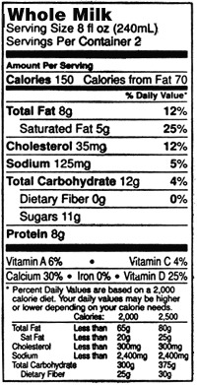
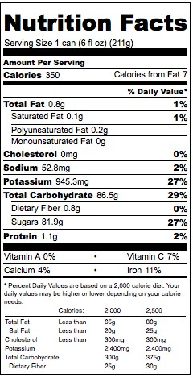
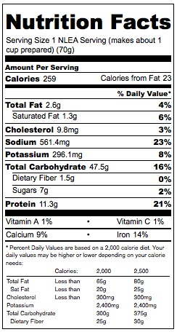
WHOLE MILK
APPLE JUICE
KRAFT MAC N’ CHEESE

Air is Important For Movement

Many people think that we breathe because we need oxygen to live. That is only partly right. They have left out an important part of the explanation of why we breathe. They have not explained WHY we need oxygen or HOW the body uses that oxygen. A good explanation that explains why we need oxygen or how the body uses oxygen might be that we breathe so our cells get oxygen to combine with food. That is how our cells get the energy that is stored in food. You have learned how food reaches your cells, but what about oxygen? How does oxygen reach your cells?

Let’s answer that question by following one breath of air that you breathe.

How does oxygen get to all of your cells?
Air contains oxygen, which your cells need, as well as many other things that your cells do not need. Some of those other things are gases such as nitrogen, carbon dioxide, and water vapor. Air also has bits of dust and smoke and pollen in it. But air is mostly made up of gas. These gases are taken inside the body.

Your lungs
With every breath, your lungs fill up with air. Most of that air, including all of the materials your body doesn’t need, you breath right back out again. But you don’t breathe out all of the oxygen that you breathe in. Some oxygen stays in your body and goes to all your cells. That means that some of the gases you take into your body stay in your body and travel all the way to your cells.

Do you have an idea how oxygen gas gets to your cells? Talk with your classmates about how you think this happens.

To your blood
Your blood carries both food and oxygen to your cells. The inside of your lungs is sort of like a sponge. Lungs have lots of tiny spaces for the air to go into, and each one of these spaces is surrounded by tiny blood vessels. Some of the oxygen gas from the air goes into the blood.

To your cells
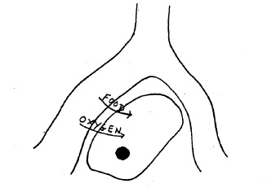
From your lungs, the blood takes oxygen to the cells in all parts of your body. Your cells get the energy they need by taking both food and oxygen out of your blood. Remember, we breathe so our cells get oxygen to combine with food. That is how our cells get the energy that is stored in food.

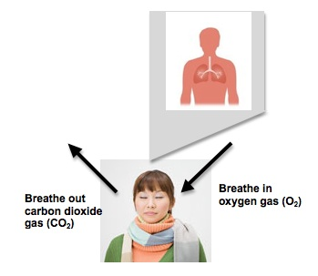
Think about what you have learned about oxygen and talk about the following question with your classmates:

Have you ever heard that people breathe in oxygen and breathe out carbon dioxide? You know what happens to the oxygen that we breathe in, but why do we breathe out carbon dioxide? If we breathe out carbon dioxide, where does it come from?

What Is Cell Respiration
Animals need food and air to help them grow, move, and keep all their body parts functioning. You learned that animals can grow and move when food and air gets to their cells. But what happens to those materials when they reach the cells.

Let’s think about a single cell, one of your brain cells, for instance. Your brain cell needs energy to think about reading this page. How will it get that energy?
At first the energy that the cell needs is stored in food as chemical energy. The food is carried by the blood to the cells. The blood also has something else that the cell needs to get energy from food, oxygen. The cell gets food and oxygen from the blood.

Now that the cell has food and oxygen, it can get the energy it needs. It changes the chemical energy found in food into other usable energy, such as motion energy, heat, and other forms of chemical energy. When it changes food, the cell makes waste products that it doesn’t need: carbon dioxide and water. How can it get rid of those waste products? Give them back to the blood, of course!
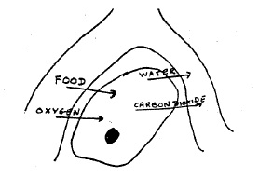
As cells work, they give off carbon dioxide and water that they do not need. These materials leave the cells and go back into the blood vessels. Eventually the water and carbon dioxide leave our bodies. Carbon dioxide leaves when we breathe out. Water leaves when we breathe, sweat, or even as urine.
Cells get chemical energy from food through cellular respiration. Cellular respiration is the process by which cells change chemical energy into usable energy by combining food and oxygen. Scientists call this cellular respiration because it happens in every single cell, not just in the lungs or in the stomach. Right this very second, every one of your trillions of living cells is getting its energy from combining food and oxygen you get from eating and breathing!

You eat many different kinds of food, but your body changes all of them to glucose. Glucose is the energy-containing food that cells use for respiration. When cells combine glucose with oxygen, the cells change the chemical energy stored in the glucose. The energy changes into new forms: motion energy and heat. Think about the type of energy form you observe when you walk or run, or how your body temperature stays around 98.6°F. There are also two matter products that the cells don’t use. These matter products are carbon dioxide and water.

The equation below shows how matter and energy change in cells:

MATTER Glucose + Oxygen → Carbon dioxide + Water
ENERGY Chemical Energy → Motion Energy + Heat

This means that glucose (food) and oxygen react and eventually the atoms that make up these materials are rearranged into carbon dioxide and water. The chemical energy that was in the glucose changes forms. It changes into motion energy and heat.

* This activity was originally developed by Hui Jin.
This article was developed from two sources: Rogers, L. (1992). Watchable wildlife: the black bear. USDA Forest Service, North Central Forest Experiment Station, St. Paul Minnesota. Lundberg, D. A., Nelson R. A., Wahner, H. W., Jone, J. D. (1976), Protein metabolism in the Black bear before and during hibernation. Mayo Clinic Proceedings. 51(11): 716-22.

